**WEB TECHNOLOGY**

**Name - Aniket Chatterjee**

**Roll No - 2005783**

**Section - CSE26**

**LAB - 1**

**DATE-20/01/2022**

**Q1.Write a basic HTML program to display your personal details (like Name, age, sex,address, contact no. etc.) in different styles.**

**CODE--**

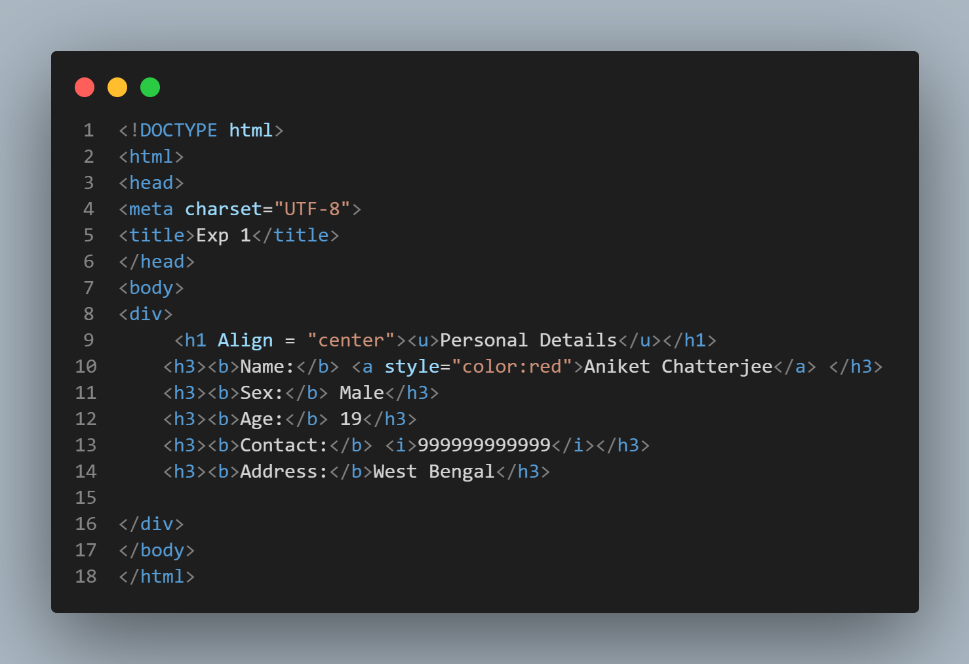

**OUTPUT--**

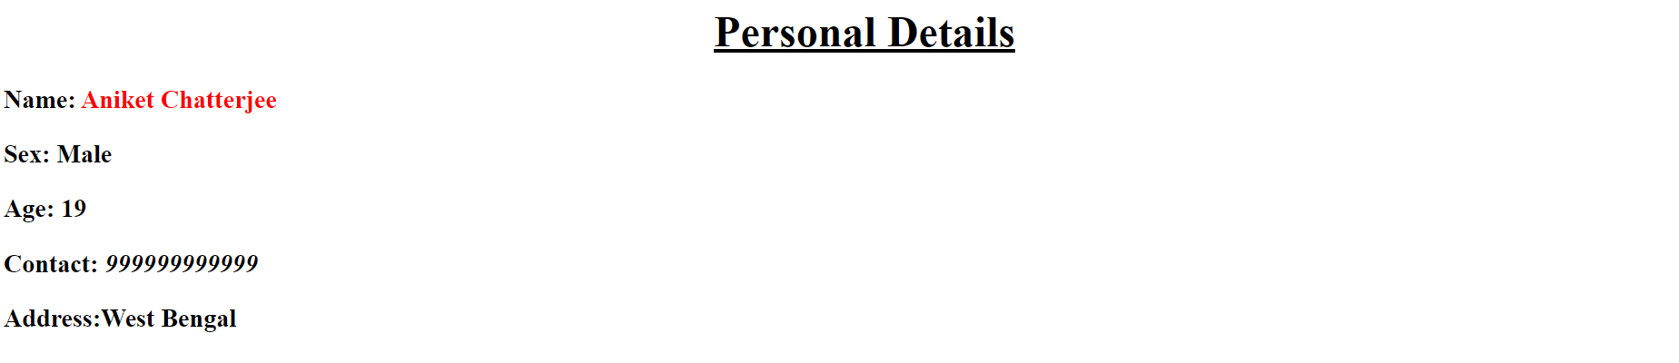

**Q2. Design a web page using inline style applied on &lt;h1&gt; tag using style attribute which will display the following output:**

**CODE--**

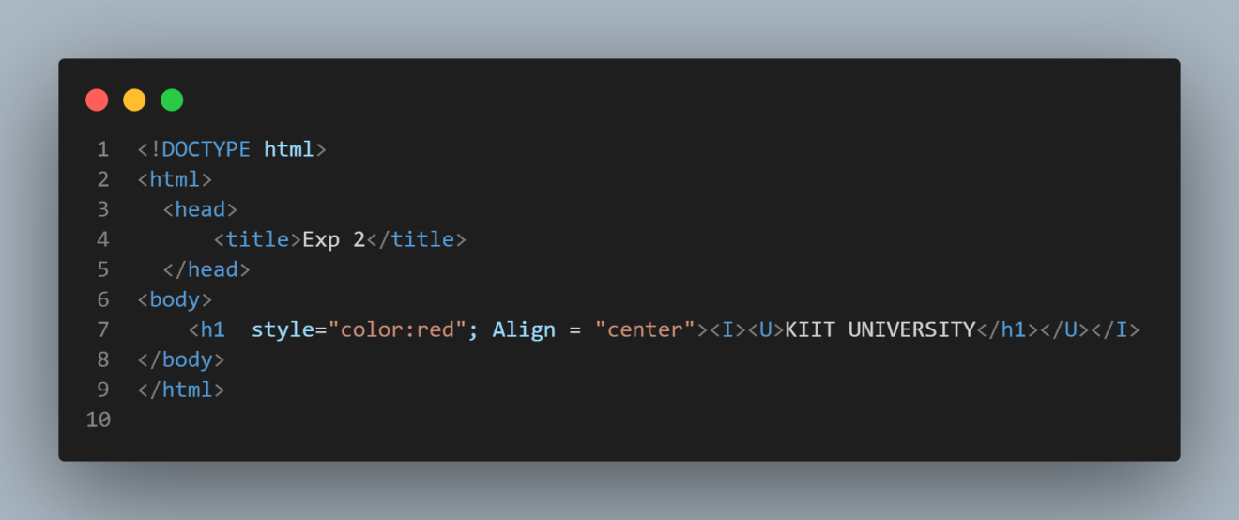

**OUTPUT--**



**Q3.Design the same web page as shown in Exp2 using internal style sheet.**

**CODE--**

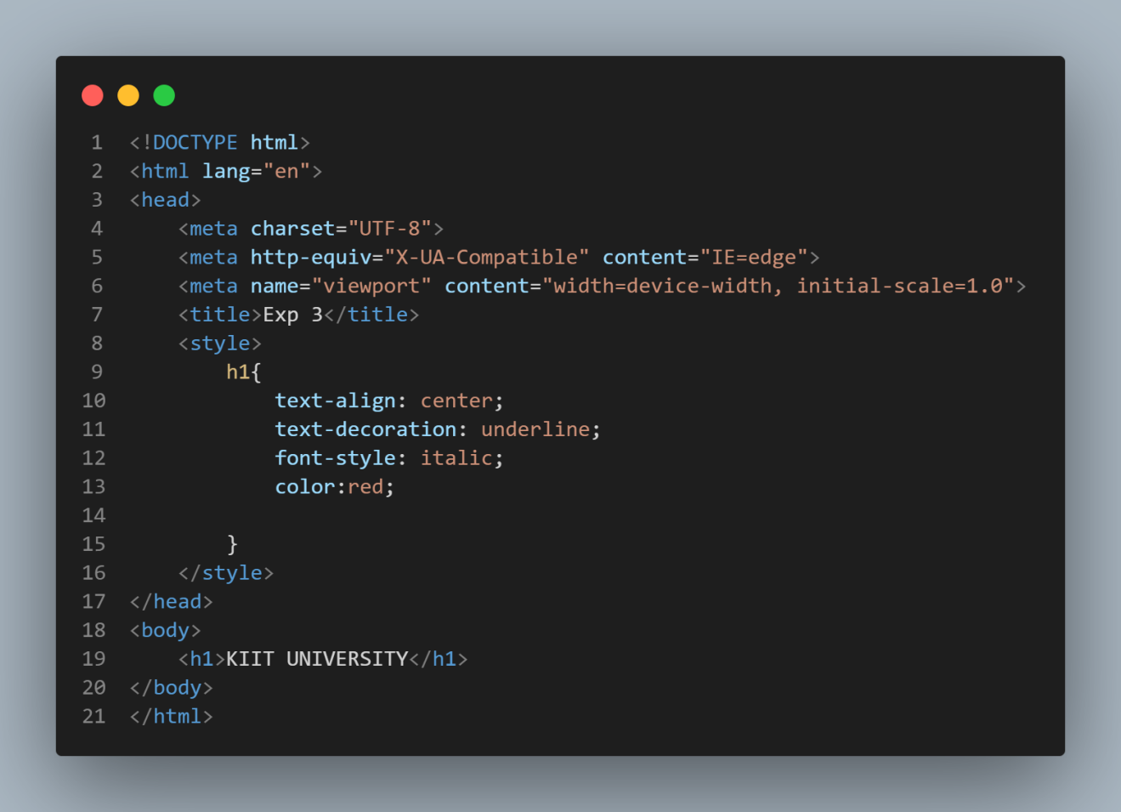

**OUTPUT--**



**Q4.Design the same web page as shown in Exp2 using external style sheet.**

**CODE--**

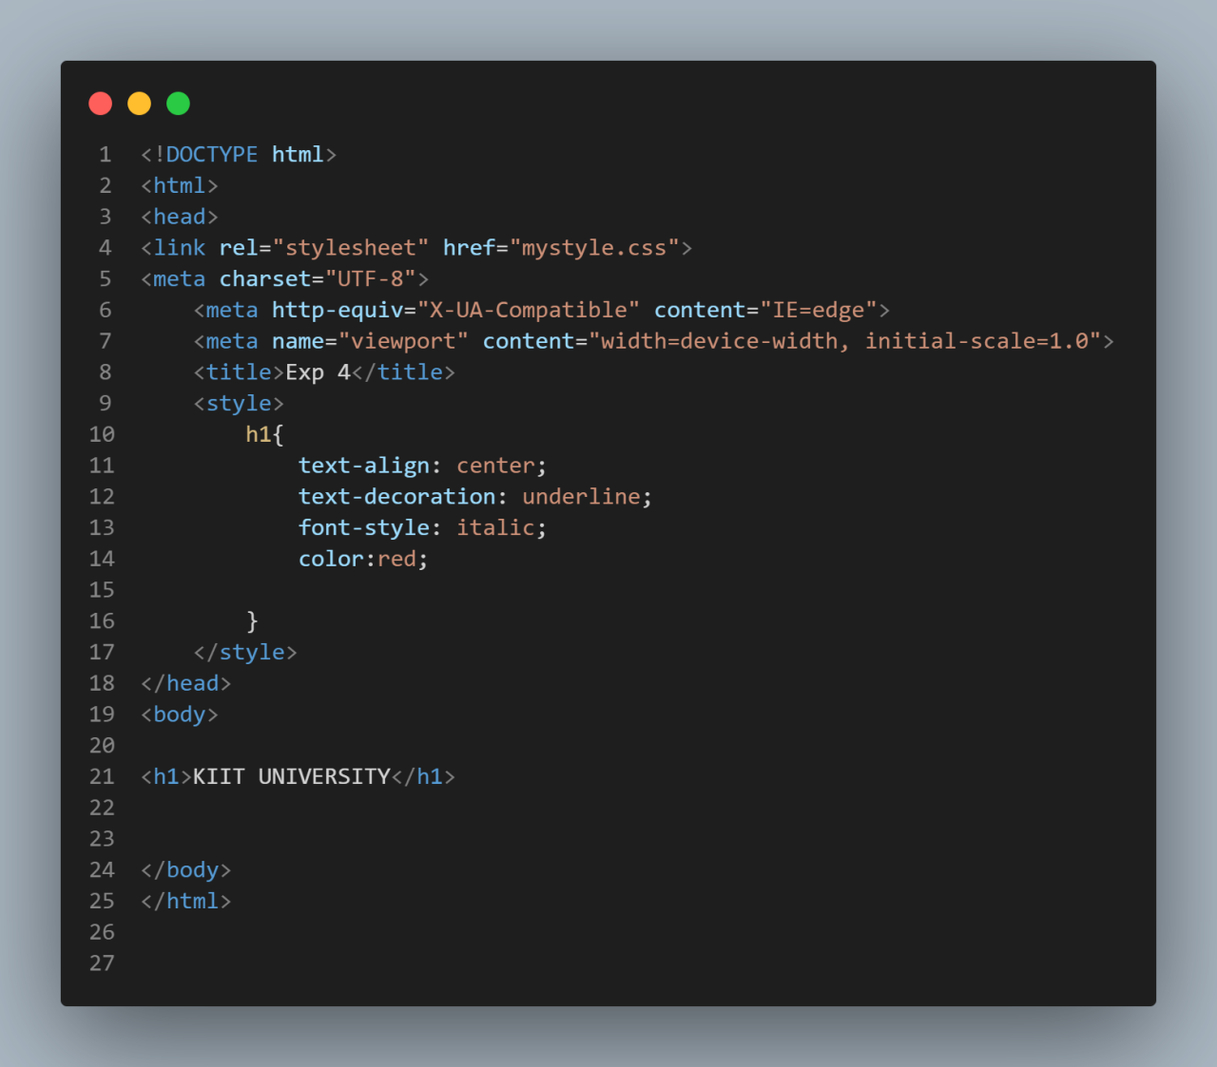

**OUTPUT--**

**Q5.**

**CODE--**

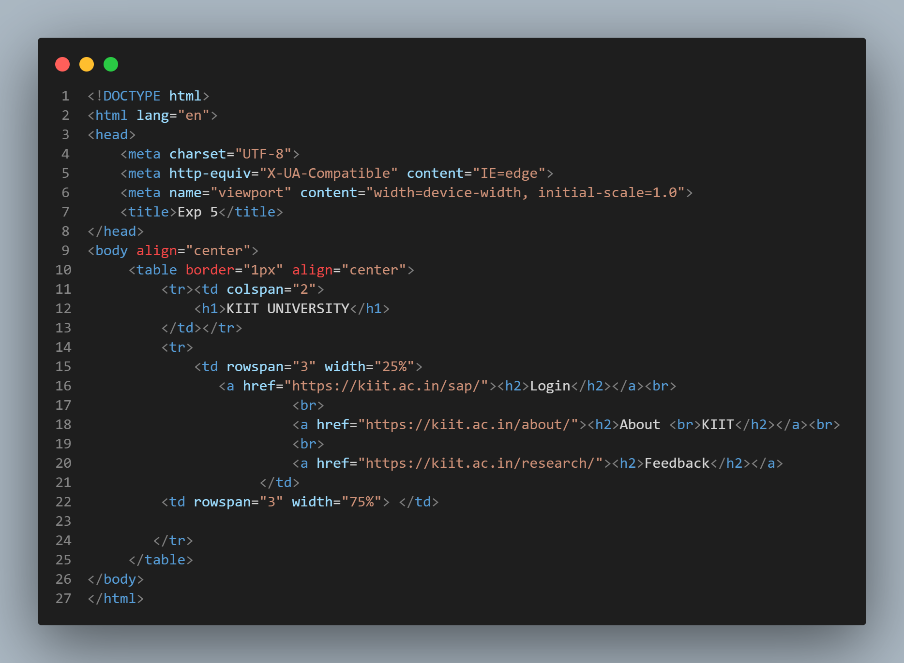

**OUTPUT--**

